Specification
RedStorm™ 2.0 Parking Guidance System
May 2014

- General
  - Introduction
This document provides the general specification, description and functional requirements for the RedStorm™ 2.0 Parking Guidance System.
  - Description of the System
The RedStorm 2.0 Parking Guidance System is a stand-alone vehicle counting system that runs on its own multi-bus 485 network. It can function as a global count or level by level count system, and is scalable and reconfigurable in the field. The system components include overhead Redzone™ Infrared Sensors for vehicle detection, Differential Zone Counters (DZ Counters) for count collection, Space Available LED (light emitting diode) signs for displaying the number of available parking spaces to motorists, and the SuperMaster Control Center for system control.

- Description of Operation
  - Simple vehicle count system. No PC required for normal operation. Open source protocol allows access to real-time count data for integration with 3rd party parking management software. Integration by others.
  - RedStorm System can operate as a stand-alone system or in conjunction with a revenue control system.
  - The System utilizes infrared sensing technology as the standard approach to vehicle detection. It can also interface with other sensing technologies that provide a dry contact relay, such as inductance loops or gate operation (supplied by others).
  - Redzone Infrared Sensors support unidirectional and bidirectional traffic flow. Their sensing overlap has ability to filter pedestrian traffic and narrow 3" deep sensing zone prevents tailgating miss-counts.
  - The system supports both global facility counting and level by level counting, as well as multiple entry and exit points at the same facility.
  - By counting vehicles and knowing the capacity of each zone, RedStorm 2.0 can calculate the number of open parking spaces.
  - The SuperMaster Control Center communicates updated space counting to signage in real-time.
  - The System has a built in automatic count reset feature to simplify maintenance.

- RS485 Network Requirements
  - Daisy-chain network topology required. (Refer to 3.6 for typical system topology.)
  - Must conform to EIA/TIA-485-A standards.
  - Maximum communication cable length should not exceed 4,000 feet for each RS-485 network.
  - Each RS-485 network can support up to of 32 devices. DZ Counters and sign displays are considered individual devices.
  - Properly grounded communication and power wiring should be run through separate conduits to avoid cross-over interference. Additional protection against voltage transients on the network is highly recommended.
  - Typical System Topology

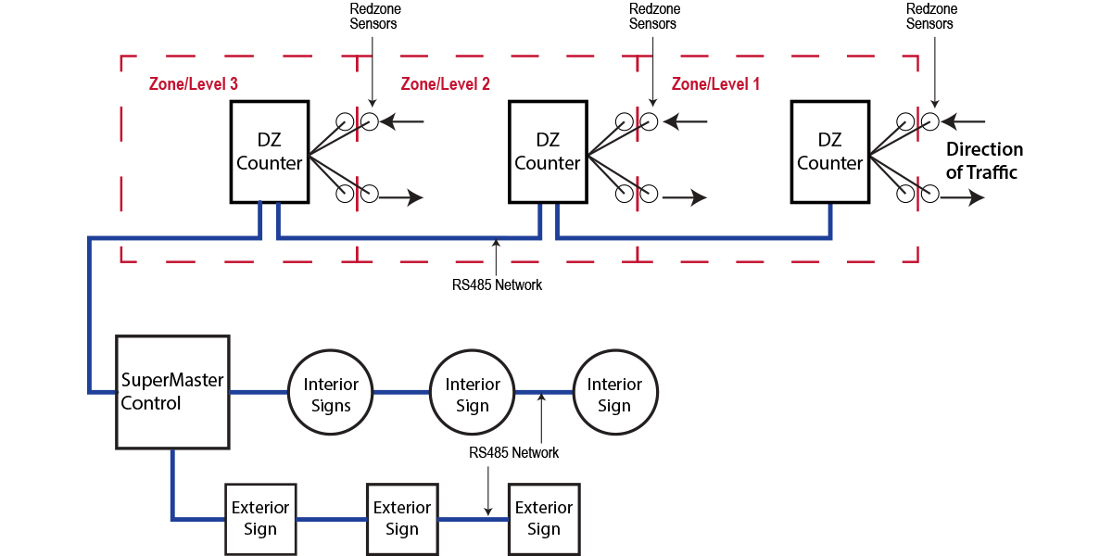

- System Components

  - RedStorm 2.0 SuperMaster Control Center
The SuperMaster Control Center gathers data from each transition point and updates the zone counts, updates all signage and logs important statistics. The Control Center consists of one SuperMaster Controller, one to multiple Auxiliary Displays for viewing sign counts remotely and one 120 Volt Power Supply. Components are mounted on a panel and enclosed in a NEMA 4X rated enclosure.

Electrical: | Voltage 100-240VAC
 | 1 Amp at 120VAC
 | Internal, Real-Time Clock
Communications | Supports 8 separate RS-485 networks
Each network supports 32 devices with maximum network length of 4,000 linear feet per network.
9600bps, 8-N-1
Display | Backlit LCD Screen; 4 lines, 20 characters
Permanent Memory | Custom formatted, factory provided SD multi  media card. Prior to power interruption, counts stored in permanent memory
.
  - Differential Zone Counter (DZ Counter)
The DZ Counter monitors in/out vehicle counts at each transition and communicates them upon request to the SuperMaster Controller. Each DZ Counter can support up to two (2) sensor pairs or four (4) loop detection units. The DZ Counter is housed in a NEMA rated enclosure.

Electrical: | Available in low volt, 120V, or 240 VAC
Communications | RS485 Network Port
Sensor Inputs | Four (4) Sensors Connections

  - Redzone Infrared Overhead Sensor
Installed in pairs with each DZ Counter. Sensors are used to detect vehicles and their travel direction. Sensors are capable of unidirectional and bidirectional vehicle counting.
Electrical: | Power supplied by DZ Counter. DC Power 12-24 VDC, 100mA maximum consumption
Communications | Each sensor includes a 16 foot long cable for connecting the sensor to its corresponding DZ Counter. Cable may be lengthened (in the field by others) to a maximum of 350 feet using 4 conductor, 18 gauge cable.
Temperature Range | -4 degrees to 140 degrees Fahrenheit

  - Space Available Signage
Custom designed signs with LED 7-segment boards for displaying counts. Signage is sized to display counts for a single level or entire garage.

Construction | Pre-wired, corrosion resistant, mitered extruded aluminum cabinet with factory applied interior anti-condensation coating.
Finish | Fade resistant, automotive grade paint. Graphics in high performance, commercial grade vinyl; computer cut, factory applied.
Mounting | Wall, ceiling, direct burial post mount, or base plate post mount.

