Specification
RedStorm™ 2.1 Parking Guidance System
June 2019

- General
  - Introduction
This document provides the general specification, description and functional requirements for the RedStorm™ 2.1 Parking Guidance System.
  - Description of the System
The RedStorm 2.1 Parking Guidance System is a stand-alone vehicle counting system that runs on its own multi-bus 485 network. It is TCP/IP enabled and can be connected to the facility network with Signal-Tech’s Sign Control and Reporting Software. It can function as a global count or level-by-level count system, and is scalable and reconfigurable in the field. For expanded functionality, the RedStorm 2.1 System can be integrated with both RedStorm Sign Control and Reporting Software and Smart Signs.

The system components include:
- Signal-Tech Overhead Sensors for vehicle detection
- DZ Counters (differential counter) for count collection
- Space Available LED signs for displaying the number of available parking spaces to motorists
- SuperMaster Controller for system control
- Optional
  - RedStorm Sign Control and Reporting Software for collecting, monitoring, reporting and sharing parking data, and
  - Smart Signs for directional traffic control.

- Description of Operation
  - RedStorm System can operate as a stand-alone system without software (no PC required); it can be connected to the facility network with the RedStorm Sign Control and Reporting Software; or integrated with Signal-Tech Smart Signs and the RedStorm Sign Control and Reporting Software.
  - The System utilizes infrared sensing technology as the standard approach to vehicle detection. It can also interface with other sensing technologies that provide a dry contact relay, such as anti-tailgating inductance loops or gate operation (both supplied by others).
  - Signal-Tech Overhead Sensors supports bidirectional traffic flow. Their sensing overlap has the ability to filter pedestrian traffic and narrow 3" deep sensing zone prevents tailgating miss-counts.
  - The system supports global facility counting or level-by-level counting and can be configured to handle multiple entry and exit points at the same facility.
  - By counting vehicles and knowing the capacity of each zone, RedStorm 2.1 can calculate the number of open parking spaces.
  - The SuperMaster Controller communicates updated space counts to Space Available Signs in real-time and to the Sign Control and Reporting Software when integrated.
  - The System has a built-in Occupied Space Count Reset Feature to simplify maintenance.

- RS485 Network Requirements
  - Daisy-chain network topology required. (Refer to 3.6 for typical system topology.)
  - Must conform to EIA/TIA-485-A standards.
  - Maximum communication cable length should not exceed 4,000 feet for each RS-485 network.
  - Each RS-485 network can support up to of 32 devices. DZ Counters and sign displays are considered individual devices.
  - Properly grounded communication and power wiring should be run through separate conduits to avoid cross-over interference. Additional protection against voltage transients on the network is highly recommended.
  - Typical System Topology

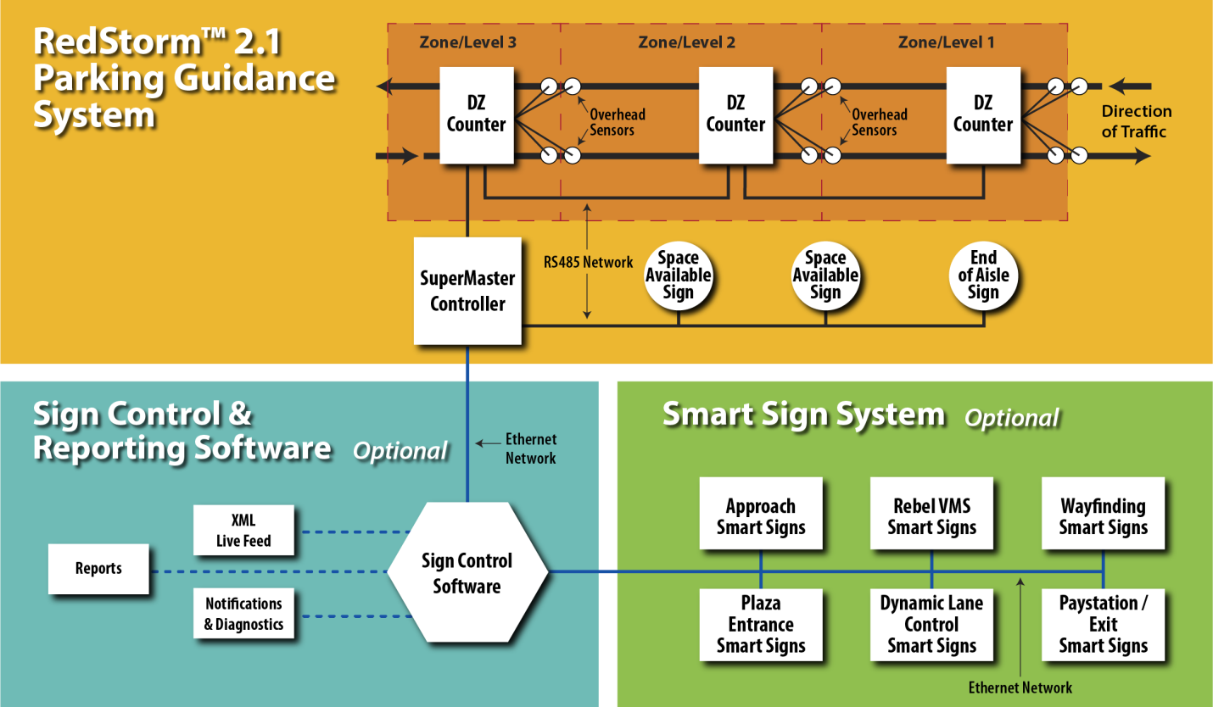

- System Components

  - RedStorm 2.1 SuperMaster Controller
The SuperMaster Controller gathers data from each transition point and updates the zone counts, updates all signage and logs important statistics. The Control Center consists of one SuperMaster Controller with an Ethernet port and a 120-240VAC power supply for input power. Components are mounted on a panel and enclosed in a NEMA 4X rated enclosure.

Electrical: | Input voltage 120-240VAC
 | <0.4 Amp @ 120VAC
 | Internal, Real-Time Clock
Communications | Supports eight (8) RS-485 network buses
Each bus supports 32 devices with maximum network length of 4,000 linear feet
9600bps, 8-N-1
Display | Backlit LCD Screen; 4 lines, 20 characters
Permanent Memory | Custom-formatted, factory-provided SD multi-media card.  Prior to power interruption, counts stored in permanent memory
Optional Network Requirements | When connecting to RedStorm Sign Control and Reporting Software use Ethernet DHCP static IP lease.
.
  - DZ Counter
The DZ Counter monitors in/out vehicle counts at each transition and communicates them upon request to the SuperMaster Controller. Each DZ Counter can support up to four (4) Signal-Tech Overhead Sensor pairs or eight (8) third-party anti-tailgating loop detection units. The DZ Counter is housed in a NEMA 4X rated enclosure.

Electrical: | Input voltage 120 – 240VAC <0.25 Amp @ 120VAC
Communications | RS485 Network Port
Sensor Inputs | Four (4) Signal-Tech Overhead Sensor pair connections or eight (8) third-party anti-tailgating loop detection units

  - Signal-Tech Overhead Sensor
Installed in pairs with each DZ Counter. Sensors are used to detect vehicles and their direction of travel. Sensors are capable of bidirectional vehicle counting.
Electrical: | Power supplied by DZ Counter. DC Power 12-24VDC, 100mA maximum consumption
Communications | Each sensor includes a 16 foot long cable for connecting the sensor to its corresponding DZ Counter. Cable may be lengthened (in the field by others) to a maximum of 350 feet using 4 conductor, 18 gauge cable.
Temperature Range | -4 degrees to 140 degrees Fahrenheit
  - Space Available Signage
Custom designed signs with LED 7-segment boards for displaying counts. Signage can be sized to display counts for a single level, entire garage or campus-wide setting.

Electrical | Input voltage 120-277VAC or 12-24VDC
Construction | Pre-wired, corrosion resistant, mitered extruded aluminum cabinet with factory applied interior anti-condensation coating.
Finish | Commercial grade reflective vinyl; full color graphics and logo branding; fade resistant, high-performance, acrylic polyurethane enamel finish.
Mounting | Wall, ceiling, direct burial post mount, or base plate post mount.

  - Signal-Tech Sign Control and Reporting Software (Software), optional
    - The Sign Control and Reporting Software organizes and manages RedStorm Systems and Smart Signs on the facility network.
Computer Requirements | Server grade PC with power backup running Windows 7 or Windows Server 2008 or higher  Minimum requirements:  8 GB RAM and 128 GB of hard drive space
Network Requirements | Ethernet  DHCP enabled

    - Functionality with the RedStorm Parking Guidance System
      - Collects and stores RedStorm System parking data
      - Has ability to interface with one or multiple RedStorm Systems on the network.
      - Monitor garage/lot usage
      - Adjust counts and capacities within a zone or system
      - Assign common names to entrances, exits and transitions to simplify reporting, maintenance and troubleshooting
      - Schedule count maintenance by zone
      - Sends email alerts when atypical system activity occurs
      - Export data in .csv format
      - Create customize parking usage reports, trend and turnover analysis, predictive analysis
      - Use to reconcile revenue for theft prevention
      - Supports a live XML feed of available space counts, giving the users the ability to display open space counts through web services
    - Additional functionality when integrated with a RedStorm System and Smart Signs
      - Display counts on space available signs in remote locations via Ethernet
      - Control wayfinding and directional Smart Signs based on real-time parking occupancy, event, day and/or time
      - Manage garage and traffic from one platform
    - Compatible with the following Signal-Tech Smart Signs
      - S-TCL Series Outdoor Blank-out Direct-view LED signs
      - S-SA Series Space Available Signs
      - S-PHX Series Outdoor Blank-out LED Backlit Signs
      - S-PHXF Series Outdoor LED Backlit Signs
      - S-TCIL Series LED Traffic Controllers
      - S-VMS Series Rebel Programmable Displays
      - S-LPS Series LED Panel Signs

  - Signal-Tech LED Smart Signs, optional
Intelligent LED signs connected to the facility network and controlled through the Software’s user defined, perpetual weekly schedule and/or conditional parameters associated with real-time parking data from a RedStorm System.
Electrical (input voltage at the sign) | 12-24VDC or 120-277VAC Based on sign series  UL/cUL Listed for wet locations
Communications | A wired Ethernet network connection at the sign and a static IP lease on the network
Illumination & Construction | LED illumination. Construction varies by sign series
Finish | Duranodic Bronze. Custom paint colors or color match services available.
Mounting | Surface, ceiling, side, post and recessed mounting available

