FAQs: Sign Control Software
The following FAQs apply to software installations for both Smart Signs and RedStorm Parking Guidance System (may be referred to as “Sign Control and Reporting Software”)
Tip: Use Ctrl + F to find what you’re looking for. Each topic has several searchable tags listed.
Contents
General Software FAQs 3
Is there an app for the Sign Control Software? (How to access the web interface) 3
Is there a subscription fee? How many licenses are included? 3
How frequent are updates to the Sign Control Software? How are updates delivered? 3
Is there an evaluation/demo copy of the software? 4
What steps are involved in setting up the software? How long does this typically take? 4
Will RedStorm continue to count vehicles if the software/server goes down? What happens during a network outage? 4
What happens when a Smart Sign loses power? Communication? 5
Do Smart Signs or the RedStorm SuperMaster support POE? 5
Do Smart Signs or the RedStorm SuperMaster support WiFi/Wireless communication to the Sign Control Software 5
Can sign brightness be set to a schedule? Is there automatic photo-dimming? 6
Can schedules be used for multiple signs? 6
Device Management, Network Security, and Other FAQs for IT Admins 7
Summary of device management and network security features 7
Can the devices (Signs and SuperMaster Controllers) be assigned static IPs instead of DHCP reservations? 7
Where can the Sign Control Software be hosted? 8
What are the default ports and protocols used by the Sign Control Software? 9
Can a device’s default communication port be changed? 10
Is an external database (e.g., SQL) required for the Sign Control Software to be installed? 11
How to disable Telnet, SNMP, and other non-essential communications on a Smart Sign or RedStorm SuperMaster? 11
Can the XPort (on Smart Sign Controller or SuperMaster) be reset to factory defaults? 11
How to migrate the Sign Control Software to another machine? 12
Can the MAC addresses of all devices be provided prior to installation? 13
Can the sign’s serial number be accessed in the software? 13
Where can the software’s config, log, and debug_log files be found? 13
What Operating System (OS) is running on Smart Sign devices? 13
How often are firmware updates released for devices (Smart Signs, SuperMaster Controllers)? 14
Are Signal-Tech devices susceptible to the Log4J/Log4Shell vulnerability (November 2021)? How are these types of vulnerabilities and exploits handled by Signal-Tech? 14

General Software FAQs
Typically asked by end users and installing partners prior to installation.

Is there an app for the Sign Control Software? (How to access the web interface)
Tags: Mobile app, iOS, Android, Web Interface, HTTP/HTTPS
There is currently no mobile “app” for the Sign Control Software; however, the software does generate a web interface that can be accessed from a phone, tablet, or laptop running any modern web browser.
Tip: If multiple users in your organization need access to the admin interface, the host machine can be made reachable via Remote Desktop (RDP).
How to access the web interface (locally):
The web interface, when enabled, should always be reachable on the host machine at http[s]://localhost:[port number]/ (specifying the port number is only necessary when it’s not set to 80 or 443 in the software)
How to access the web interface (from other devices/networks):
The software’s web server is self-contained and does not require an external server (E.g., Microsoft IIS). The host machine’s IP address must be made accessible (e.g., through port forwarding) by your organization’s network/IT administrator.
Related: Where can the Sign Control Software be hosted?

Is there a subscription fee? How many licenses are included?
Tags: Software licenses, subscription fees, recurring costs
The Sign Control Software comes at a one-time cost from Signal-Tech. This includes a single license which is validated by the software’s serial number (entered upon downloading from www.signal-tech.com/signcontrolsoftware or www.signal-tech.com/redstormreportingsoftware).
However, the installing partner may choose to host the software on a cloud platform or virtual machine (VM) which could incur a monthly fee to the end user.
Related: Where can the Sign Control Software be hosted?

How frequent are updates to the Sign Control Software? How are updates delivered?
Tags: Software updates, subscription fees, how to update
2-3 times a year. These updates can contain security patches, feature updates, and bug fixes.
The software’s admin interface has a Check for Updates button that will check Signal-Tech’s website for the latest version (requires internet access).
Alternatively, a new version of the software can be downloaded directly from our website using the download link and original serial number.

Is there an evaluation/demo copy of the software?
Tags: Demo software, extra software licenses, software installation
For “demo” purposes: Please consult a Signal-Tech sales representative to obtain a free copy of the “Sign Control Software Demo,” complete with fully-configured virtual signs and RedStorm systems.
To install software prior to physical installation: I.e., the software is required after ordering but prior to receipt (for configuring email/SMPT, HTTP/S, and web user settings) please consult a Signal-Tech sales representative to obtain a serial number before the order ships.
Do note that configuring signs and schedules in the software requires a physical connection to the sign(s).
Once configured, the software’s config file can be migrated to the primary machine. See How to migrate the Sign Control Software to another machine?

What steps are involved in setting up the software? How long does this typically take?
Tags: Software installation, Software Requirements, Server Requirements
Process | Estimated time | Notes
Network Configuration (signs) | 2-5 minutes per sign | Depends on desired configuration
Software Installation | 5 minutes | Includes downloading and running installer
Adding signs to the software | 2 minutes per sign | Includes adding/naming signs, assigning groups and existing schedules
Building a schedule | 5-10 minutes per sign type | One schedule per product ID
Creating VMS/RGB messages (if applicable) | 5-15 minutes per message | Heavily dependent on the message complexity
Configuring web interface (optional) | 10-15 minutes | Turning on HTTP interface, setting up firewall exceptions, configuring hosting settings, adding a user
Estimated total (low – high) | 15 – 60 minutes

Will RedStorm continue to count vehicles if the software/server goes down? What happens during a network outage?
Tags: Network setup, RedStorm, Notifications, Troubleshooting
RedStorm is a self-contained system (with its own RS-485 network) which will continue to operate regardless of the status of its LAN connection.
If there are any Smart signs used in the software (including S-SA signs), they may be dependent upon the current RedStorm data. These signs will continue to display the most recent message set by the software, but they will not change unless connection is reestablished, or the message is overridden.

What happens when a Smart Sign loses power? Communication?
Tags: Network setup, Notifications, Troubleshooting
When a Smart Sign loses power:
The sign will blank out and lose connection to the network/software, showing an “error-state” in the software interface. An email notification will be sent (if configured) once every hour.
Once power is reestablished, the sign should resume normal operation within one minute, and an email notification will be sent. If this does not happen, verify network connectivity to the sign.
When a Smart Sign loses communication with the software:
The sign will illuminate the last message it was instructed to display (indefinitely) until connection is reestablished. The sign will NOT change its state during a communication outage.
An email notification will be sent (if configured) once every hour, plus an additional notification when the connection is reestablished.

Do Smart Signs or the RedStorm SuperMaster support POE?
Tags: Device Features, Lantronix XPort
Signal-Tech products do NOT currently support POE (updated Q2 2023).

Do Smart Signs or the RedStorm SuperMaster support WiFi/Wireless communication to the Sign Control Software
Tags: Device Features, Network Setup, Lantronix XPort, Wireless Router
No Signal-Tech products currently support WiFi as they all require a hardwired Ethernet connection (updated Q2 2023).
WiFi-to-Ethernet bridges do exist; however, depending on the device and network architecture, these bridges can introduce lag/latency between the device and the server, resulting in communication timeouts.

Can sign brightness be set to a schedule? Is there automatic photo-dimming?
Tags: Device Features, Scheduled Dimming, Software Features
Automatic photo-dimming: YES*
Scheduled dimming: NO**
*All S-TCL and S-SA signs come with on-board photo eyes and automatic photo-dimming by default.
Other product lines—S-PHX, RGB, VMS, and others—do not have automatic photo-dimming and will always be set to full brightness.
**The brightness of any Smart Sign can be overridden by the user in the software on a per-sign basis. There is currently no schedule-controlled dimming (Sign Control Software version 4.2.8).

Can schedules be used for multiple signs?
Tags: Software Installation
User-created schedules can be used for multiple signs with the same product ID. This is indicated by “Sign Type” in the software (under Signs and Schedules tabs) shown below:
Appearance in “Signs” Tab:
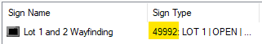
Appearance in “Schedules” Tab:
Even if two different signs have the same message set, they cannot be assigned the same schedule, since schedules are grouped by product ID (Updated Q2 2023).

[end of section]

Device Management, Network Security, and Other FAQs for IT Admins
Typically asked by IT/Network Administrators prior to, during, or after installation.

Summary of device management and network security features
Tags: Network security, Network Ports, Firewall, Infosec, Network Setup, Device Features, Software Features
Since the Sign Control Software and its supported devices can be deployed in any Windows environment—cloud-hosted, local, virtual, etc.—there’s a suite of features to support a wide range of digital security requirements.
In Sign Control Software:
- Authentication/SSL for SMTP
- HTTPS option for Web Interface
- HSTS support
- Username/Password requirements for Web Interface
- RSA1024 encryption for sensitive config information
On Smart Signs/Supported Devices:
- Password protection on web configuration interface (web GUI or Telnet)
- Options to disable device features like Telnet and SNMP
- Configurable primary TCP/IP port

Can the devices (Signs and SuperMaster Controllers) be assigned static IPs instead of DHCP reservations?
Tags: DHCP lease, network setup, Fixed IP, IP conflict, device discovery
All devices are configured for DHCP from the factory; however, all devices may be configured with static IPs.
For RGB Rebel series:
The RGB Rebel’s master controller has a pushbutton that can be used to toggle between static and dynamic IP modes. Refer to the RGB installation guide for specific instructions:
For all other Smart Signs and SuperMaster Controllers:
If a DHCP server is not available, DeviceInstaller (Lantronix) is the easiest way to discover a Smart Sign, Variable Message Sign, or RedStorm SuperMaster Controller on your network.
DeviceInstaller uses UDP to broadcast a request to all Lantronix network interfaces. It also allows you to configure a device’s network settings through its web GUI or Telnet terminal.
Here’s a quick video demo showing how to use DeviceInstaller and the Lantronix web interface:
Note: this is not a Signal-Tech video; only use as a reference for network settings. “Serial Settings” shown in the video may not apply.

Where can the Sign Control Software be hosted?
Tags: Software hosting, Cloud Software, PaaS, IaaS, SaaS, AWS, Azure
The Sign Control Software should be hosted in a Windows environment on a server-grade computer or VM.
Local or Remote?
Local or remote/cloud servers running Windows Server 2016 or newer, or a local PC running Windows 10 or newer, can host the software. This includes IaaS/cloud infrastructure services like AWS and Microsoft Azure if the above requirements are met.
Please refer to Microsoft’s hardware requirements for the specific OS being used.
Web Interface Hosting:
While a dedicated server is not necessary for the application to run, keep in mind that the software’s web interface is being hosted by that machine, which may present conflicts with other web services.
Tip: if a simple LAN setup is desired, the software can run in an isolated environment with no internet access (software updates will not be available).
See Network Topology Diagram here: What are the default ports and protocols used by the Sign Control Software?

What are the default ports and protocols used by the Sign Control Software?
Tags: Network Ports, Firewall Rules, Network Security, Network Setup, Software Updates, Software Topology
IT personnel may need to know this so they can set up specific firewall exceptions on the machine hosting the software.
Label | Device/Feature | Default Port (Protocol) | Primary Direction | Frequency/Trigger | Notes
A | Smart Signs | 10001 (TCP/IP) | From HOST | Per minute | Port configurable on host and client
B | RedStorm SuperMaster | 10001 (TCP/IP) | From HOST | Per minute | Port configurable on host and client
C | Web Interface  (includes XML feed) | 80 (HTTP)  443 (HTTPS) | From CLIENT (user) | Per 1-5 minutes (when logged in) | Port configurable;  TLS 1.2 (as of v3.0.14)
D | Admin Interface | Varies | Bidirectional | Varies | Admins only (per group policy)
E | Email Notifications | 25 (SMTP, SSL) | From HOST | Varies  (event-based) | Port configurable
F | Software Update Check | 443 (HTTPS) | From HOST | User-prompted | As of v3.0.15
G | Sign configuration  (web or Telnet) | 80 (HTTP)  9999 (Telnet) | From CLIENT (admin) | User-prompted | Used for device setup (e.g., setting IP address)
H | Debug log transfer | 21 (FTP) | From HOST | User-prompted | Only used upon request
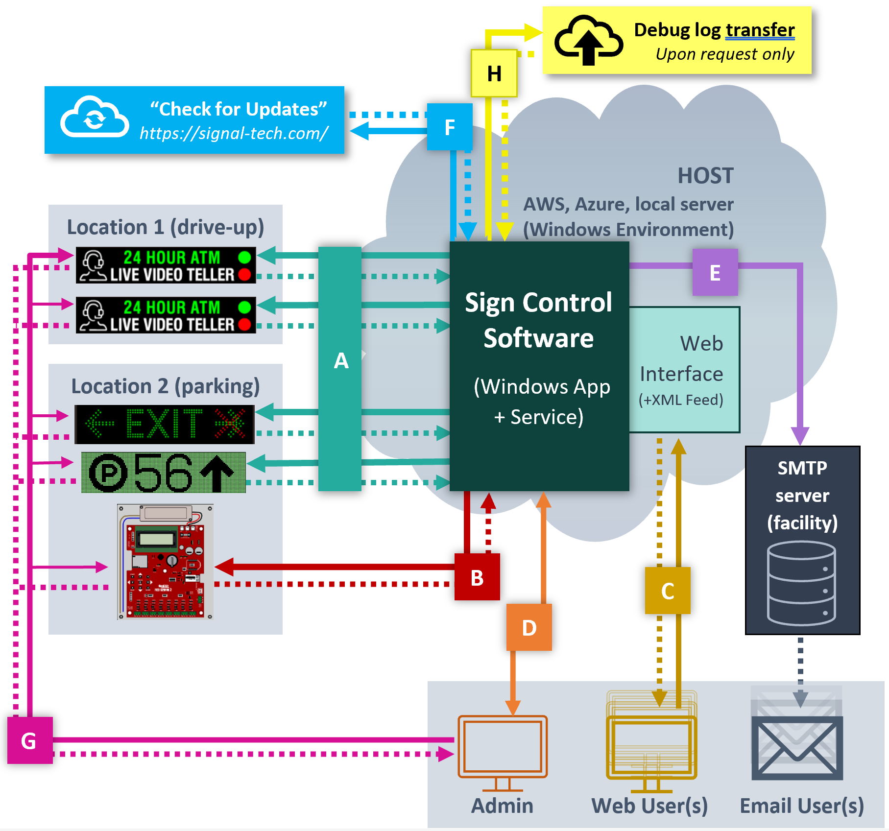
Related: Can a device’s default communication port be changed?

Can a device’s default communication port be changed?
Tags: Network Ports, Firewall Rules, Network Security, Network Setup, Software Updates
The default communication port used between the Sign Control Software and the Smart Signs (or RedStorm SuperMaster devices) is 10001, but can be configured differently by changing two things:
- The device’s “Endpoint Configuration” settings (notes below)
- The “Port” value in the Sign Control Software (in the “Add Device” window)
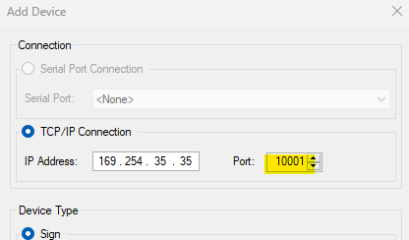
Note: To change the device’s settings, go to its web GUI in a browser and navigate to the page shown below:

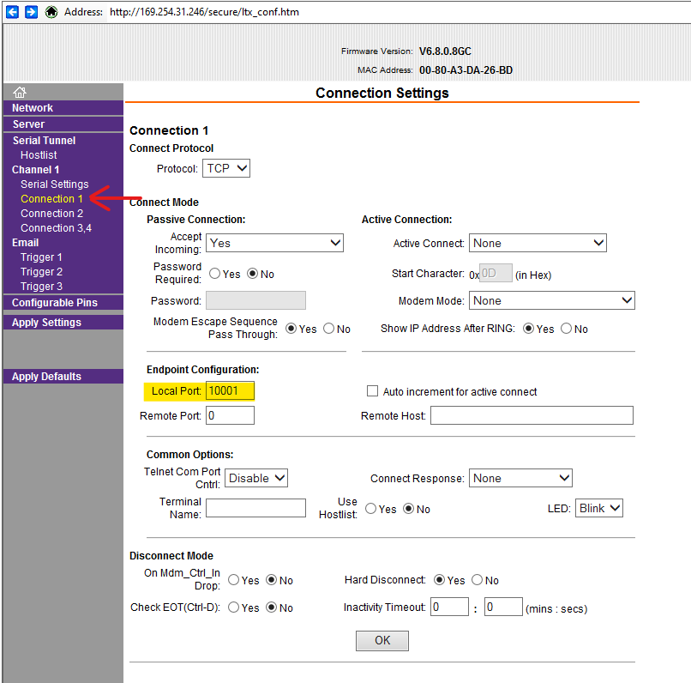 | - Go to Connection 1  - Find Local Port and change to the desired port value  - Click OK  - Once all desired changes have been made, click Apply Settings on the left-hand menu

Is an external database (e.g., SQL) required for the Sign Control Software to be installed?
Tags: Software Installation, Software Features, Software Hosting
No; The Sign Control/Reporting Software uses its own SQLite database to store RedStorm Parking Guidance System data.
Other information is stored in the software’s configuration and log files.
Related: Where can the software’s config, log, and debug_log files be found?

How to disable Telnet, SNMP, and other non-essential communications on a Smart Sign or RedStorm SuperMaster?
Tags: SNMP, 77FEH, Telnet, XPort, Network Security, Network Setup
Many of our products utilize Lantronix/GridConnect’s embedded network devices which may come with some settings enabled by default.
SNMP, Port 77Feh, etc.:
Any changes to these settings must be made through Telnet. Refer to GridConnect’s documentation here to find instructions for disabling these defaults.
Telnet:
Important: Disabling Telnet will permanently disable access to other settings relevant to your network security protocols (SNMP, Port 77Feh, etc.)
Telnet can be disabled in the Telnet terminal, which can be accessed via DeviceInstaller or through a standard terminal like PuTTY. Telnet can be accessed over port 9999.
Related: Can the XPort (on Smart Sign Controller or SuperMaster) be reset to factory defaults?

Can the XPort (on Smart Sign Controller or SuperMaster) be reset to factory defaults?
Tags: Lantronix XPort, NIC Card, Network Security, Factory Defaults, Password Reset
The NIC (a.k.a “XPort”) used on the Smart Sign Controller (or SuperMaster) may be reset to factory defaults depending on its hardware/firmware version (updated Q4 2024).
Hardware reset (available on Smart Signs manufactured after 4/9/2024):  Verify that the version sticker (as shown in the blue square) is 50458.4 or higher. Older versions do NOT have a hardware reset.  Then, press and hold the orange button (orange circle) for 5s, then release. The TX/RX (red arrow) LEDs should begin flashing rapidly. | 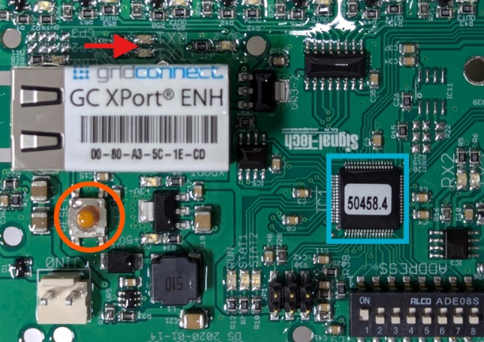

How do I migrate the Sign Control Software to another machine?
Tags: Software backup, software migration, license transfer, demo copy
Important: do not allow two instances of the software to run on the same network simultaneously
Step 1: Obtain installer (.exe) file
Find the original downloaded installer: Sign_Control_Software_Setup.exe
Note: If this installer file cannot be found, please contact the Smart Sign partner (or a Signal-Tech sales representative) for the correct download link and serial number.
Step 1a: Copy/download the installer to the new host
Step 2: Transfer backup/config files
All configuration data—signs, schedules, etc.—are stored locally on the host machine in a file called config.xml:
[Drive]:\\Program Files\Sign Control Software\config.xml
Step 2a: Copy the config.xml file to a folder on the new host.

Your sign images will also need copied, found in the WebInterface folder:
[Drive]:\\Program Files\Sign Control Software\WebInterface\
Step 2b: Copy the contents of the WebInterface folder to a folder on the new host.

If there are any RGB messages using custom images, they will be stored in the Assets folder:
[Drive]:\\Program Files\Sign Control Software\Assets
Step 2c: Copy the contents of the Assets folder to a folder on the new host.

If the software is being used with a RedStorm System, the redstorm.sqlite file should also be copied over to preserve historical system data:
[Drive]:\\Program Files\Sign Control Software\redstorm.sqlite
Step 2d: Copy the sqlite file to a folder on the new host.

Step 3: Run the installer
Step 3a: Once installed, do not launch the Sign Control Software
Step 3b: Transfer the backup files (Step 2) to their respective locations on the new host
Step 3c: Launch the software and verify sign/server communication and other settings
Communication issues after migrating? See What are the default ports and protocols used by the Sign Control Software?

Can the MAC addresses of all devices be provided prior to installation?
Tags: Network setup, DHCP Reservations
MAC addresses for all Smart Signs are documented in DMS only once the signs are serialized, programmed, and tested. This is typically done within two days of the ship date.
If MAC addresses must be provided sooner, please contact the Signal-Tech sales representative who can coordinate this with the Production team.

Can the sign’s serial number be accessed in the software?
Tags: Software features, troubleshooting
In version 4.2.8 (and earlier) of the Sign Control Software, there is no way to access the sign’s serial number using the software.

Where can the software’s config, log, and debug_log files be found?
Tags: Software features, troubleshooting
config.xml file:
All configuration data—signs, schedules, encrypted user credentials, etc.—are stored in the config.xml file found in the software’s program files folder: [Drive]:\\Program Files\Sign Control Software
log.txt file:
The software, by default, will generate a log.txt file containing a record of events including:
- Sign overrides
- Web user logins
- GUI startup/shutdown
- “Sign unresponsive” messages
This file is found in the software’s program files folder: [Drive]:\\Program Files\Sign Control Software
debug_log.txt file:
debug_log.txt is used in versions 4.2.8 and earlier. We recommend updating to 4.2.9 or later for automatic logging.
For software version 4.2.9 and later, a debug_[month]_[year].txt file will be created if there are communication error events.
These files can be found in the same location as log.txt, or they can be sent directly with FTP from within the software. Go to View Log and then click Send Logs.

What Operating System (OS) is running on Smart Sign devices?
Tags: Network Security, Device Features, Updates
There is no “operating system” used by Smart Signs or RedStorm. All Smart Sign controllers (except RGB Rebel) run proprietary firmware on embedded microcontrollers.
RGB Rebel Controllers use a combination of embedded microcontrollers and a Linux-based SBC.

How often are firmware updates released for devices (Smart Signs, SuperMaster Controllers)?
Tags: Lantronix XPort, NIC Card, DeviceInstaller, Network Security, Device Features, RedStorm
While we keep our firmware up to date for production units, post-production firmware updates are very rare.
Should firmware need to be updated, the process is different depending on the embedded device in question:
Signal-Tech Controller (embedded PIC) Firmware:
The firmware used by A) the Smart Sign Controller and B) RedStorm SuperMaster are not field-updateable. If a bug is discovered and negatively impacts the performance of the device, a new controller will be provided if covered under warranty.
XPort/NIC Card Firmware:
If a firmware update is issued by Lantronix/GridConnect for the XPort module (NIC card), the device can be updated using Lantronix DeviceInstaller. There have not been any critical updates from 2018-2022, however.
RGB Rebel Controller:
Signal-Tech product support must be contacted to update RGB Rebel Firmware.

Are Signal-Tech devices susceptible to the Log4J/Log4Shell vulnerability (November 2021)? How are these types of vulnerabilities and exploits handled by Signal-Tech?
Tags: Network security, Device Features, Firmware Updates, Zero-Day
No Signal-Tech products were affected by the Log4J/Log4Shell vulnerability discovered in November 2021.
While Signal-Tech does monitor widespread vulnerabilities, bugs, etc., it is possible that lesser-known vulnerabilities may not be met with an immediate fix. Users should notify Signal-Tech (www.signal-tech.com) to inquire about specific issues that may affect devices on their network.
Related: How often are firmware updates released for devices (Smart Signs, SuperMaster Controllers)?

